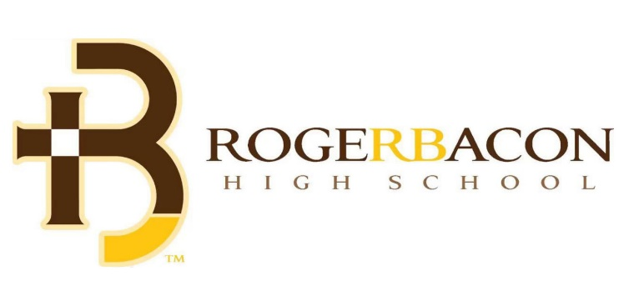

Come see why Roger Bacon has become a school of choice in Cincinnati. Smaller. Co-ed. Diverse. Uniquely Franciscan. We are Roger Bacon!
- SHADOW DAYS - NOW THROUGH DECEMBER 16 - Be a Spartan for a Day as your attend Roger Bacon for a shadow day. Make friends, meet teachers, take a tour, and experience why there is no place like Roger Bacon.
- GRADE SCHOOL NIGHTS: All elementary school students receive free admission as we invite you to come cheer the Spartans onward to victory.
  - Roger Bacon Girls & Boys Soccer vs. CCD – Sept 15, 2022, 7 pm
  - Roger Bacon Volleyball vs. SCD – Sept. 27, 2022, 6:30 pm
  - Roger Bacon Football vs. CHCA – Sept. 30, 2022, 7 pm
- REQUEST YOUR SPARTANLINK ACCOUNT: Visit www.rogerbacon.org/future-spartans to submit an inquiry and get set-up with your online application portal.
- OPEN HOUSE: Save-the-date – October 23, 1- 4 pm

